MIME 262 – Lecture 18 Wu Dongming

March 19th, 2012 Matthew Da Silva

Group 11 Diana Meca

**Semiconductors**

**Intrinsic**: the band gap is small enough that a modest concentration of free carriers is liberated by thermal activation at finite temperature, the Fermi energy is in the middle of the band gap.

The [current](http://hyperphysics.phy-astr.gsu.edu/hbase/solids/intrin.html#c2) which will flow in an [intrinsic semiconductor](http://hyperphysics.phy-astr.gsu.edu/hbase/solids/intrin.html#c1) consists of both [electron and hole](http://hyperphysics.phy-astr.gsu.edu/hbase/solids/intrin.html#c4) current. That is, the electrons which have been freed from their lattice positions into the [conduction band](http://hyperphysics.phy-astr.gsu.edu/hbase/solids/band.html#c1) can move through the material.

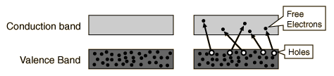

* Free electron density: At any temperature above ok some electrons occupy states in the conduction band and are free to carry current. They contribute to electron conductivity which is given by:

$σ=neμ_{e}$**;**

Where: n=number of conduction electrons/volume. And μe = electron mobility governed by scattering processes

* Conductivity

$σ e^{\frac{-E_{g}}{2KT}}$**;**

Where Eg is the band gap, K is the Boltzmann constant, and T is the absolute temperature.

**Extrinsic**: Charge carriers are due primarily to the ionization of defects in the crystal lattice. This ionization produces a density of extrinsic charge carriers that adds to the density of intrinsic charge carriers from the intrinsic activation across the band gap.

* N-type (donors): extrinsic charge carriers are electrons in the conduction band
* P-type (acceptors): charge carriers are holes in the valence band

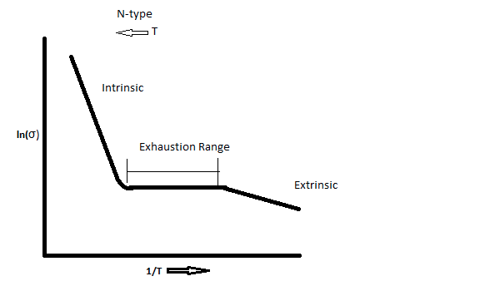

Graph showing how conductivity varies with temperature for extrinsic semiconductors

**The N-P Junction:**

P–N junctions are commonly used as [diodes](http://en.wikipedia.org/wiki/Diode): circuit elements that allow a flow of [electricity](http://en.wikipedia.org/wiki/Electricity) in one direction but not in the other (opposite) direction. This property is explained in terms of forward bias and reverse bias, where the term bias refers to an application of electric [voltage](http://en.wikipedia.org/wiki/Voltage) to the p–n junction.

At zero bias, or V = 0, the diode is at equilibrium and the Fermi energy is constant. Equilibrium is reached when the electron densities (at certain energy levels) are equal on both sides.

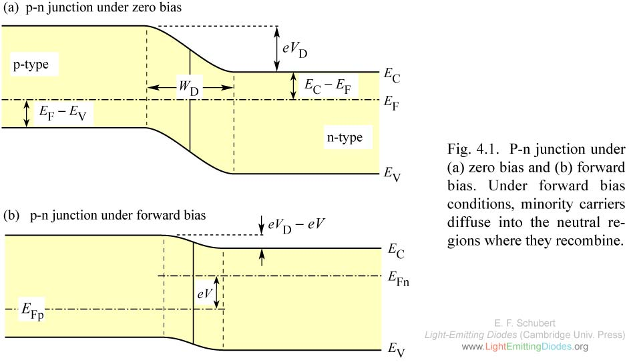

If a positive voltage is applied, the barrier for electrons and holes to be able to move is lowered (forward bias). V is positive.

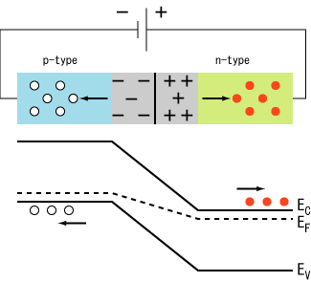

Under reverse bias, the current is due to an excess flux in minority carriers: the electrons in the p-type material and the holes in the n-type material. V is negative. The junction is steeper making it more difficult for electrons to move into the p-type side, and holes into the n-type side.

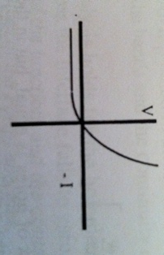

Here is the current voltage characteristic of an n-p junction diode. The reverse bias is in the –x axis region. The forward bias is in the +x axis region.

An example of one of the functions of an n-p junction diode is the **Rectifier.** When we plot the voltage vs. time characteristic of a device we observe the following plots for the input signal and the output signal.

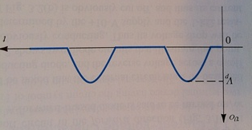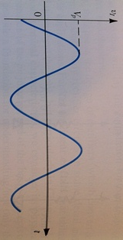

Input Signal Rectified Output Signal

**Bipolar Junction Transistor (BJT) section 14.5**

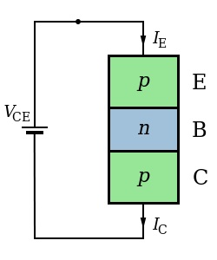

In the case to the left, the currents IE and IC are both equal to zero because the p-n-p BJT are acting like two p-n junctions in reverse bias. Therefore there is no current that passes through, regardless of the value of the voltage applied.

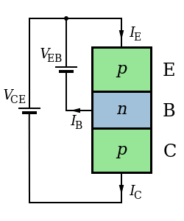

When dealing with a BJT, it is much more useful to apply another voltage directly to the n-type part of the device as demonstrated in the figure to the right. In this case, holes from the p-type section of the device can flow to the n-type allowing current to pass through the device.

**Metal Oxide Field Effect Transistor (MOSFET)**

* No current in the gate
* Used for logic application
* Used for operations on numbers
* Requires less power for operation

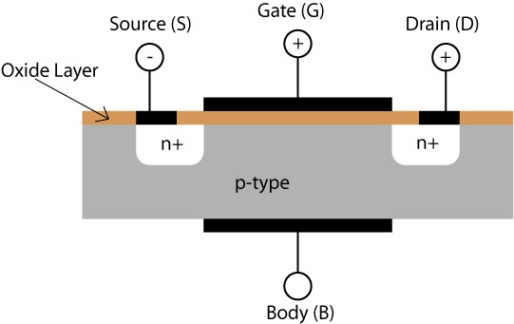

**Semiconductor Fabrication:**

Semiconductor fabrication technologies are enabled by photolithography.

Photolithography: a mechanism in which light is used to write pattern onto a chip surface.

Its purpose is to dope region of a crystal with electrically active impurities in order to create islands of n- and p-type semiconductors. These must be incorporated in the precise pattern in which they are needed for the junction elements.

Process: A semiconducting crystal is oxidized, coated with a photoresist and covered with a mask that permits radiation to strike the surface in a selected pattern.

**The first few steps to fabricating a semiconductor:**

1. Heating Silicon to about 1000C until a layer of SiO2 is formed
2. Spin Photo Resist
3. Exposure to light after placing a mask
4. Development
5. Etching
6. Ion Implant Action Doping